Table 1A. Patient and Lesion Demographics of Full Cohort (SMC-LUD, n=1,021)
항목 (Characteristics) | HCC (환자 n=600) | Hemangioma (환자 n=421)
나이, 평균 ± 표준편차 (범위), 세 | 66.65 ± 11.02 (20–90) | 55.50 ± 12.76 (30–90)
남성, n (%) | 491 (81.8%) | 174 (41.3%)
여성, n (%) | 109 (18.2%) | 247 (58.7%)
키, 평균 ± 표준편차, cm | 165.74 ± 16.39 | 163.72 ± 8.45
몸무게, 평균 ± 표준편차 (범위), kg | 67.44 ± 11.24 (42–104) | 63.85 ± 12.95 (34–118)
병변 크기 (최대 직경), 중앙값 / Q1 / Q3, cm | 2.90 / 2.10 / 4.50 | —
UICC 병기 (2000), n (%)
pT1 | 58 (9.7%) | —
pT2 | 120 (20.0%) | —
pT3 | 353 (58.8%) | —
pT4 | 69 (11.5%) | —
AJCC 병기 (2010), n (%)
pT1 | 164 (27.3%) | —
pT2 | 393 (65.5%) | —
pT3 | 22 (3.7%) | —
pT4 | 21 (3.5%) | —
Data source: Tak et al. Sci Data (2026)[13]. Values represent full SMC-LUD cohort (n=1,021 patients). Note that tumor diameter and pathological stages were only documented for HCC cases in the original public repository.
Table 1B. Dataset Allocation for Clean Subset (744 Patients, 2,656 Images)
Diagnosis | No. of Patients | No. of Images | Train Set | Validation Set | Test Set
Hemangioma | 323 | 1,267 | 886 | 253 | 128
HCC | 421 | 1,389 | 972 | 277 | 140
Total (Clean) | 744 | 2,656 | 1,858 | 530 | 268
Values follow the patient-level split published by Tak et al. (2026). Images with calipers or measuring overlays were excluded to prevent shortcut feature learning.
Table 2. Ablation: Backbone × Training Mode (Validation Set, Confidence Score)
# | Backbone | Training Mode | Cutoff | AUROC | Sensitivity (%) | Specificity (%) | F1 Score
1 | ResNet50V2 | CE Only | 0.0002 | 1.000 | 100.00 | 100.00 | 1.0000
2 | EfficientNetV2B0 | CE Only | 0.0016 | 0.9999 | 100.00 | 99.60 | 0.9982
3 | ResNet50V2 | CE + SupCon | 0.0002 | 1.000 | 99.64 | 100.00 | 0.9982
4 | EfficientNetV2B0* | CE + SupCon | 0.0011 | 1.000 | 100.00 | 100.00 | 1.0000
5 | ResNet50V2 | NNCLR (SSL) | 0.0003 | 0.9994 | 99.64 | 99.21 | 0.9946
6 | EfficientNetV2B0 | NNCLR (SSL) | 0.0038 | 0.9986 | 98.19 | 98.42 | 0.9837
*Primary model (#4). Validation comprised 530 images (277 HCC and 253 hemangioma). Cutoffs were determined using Youden's J statistic. EfficientNetV2B0 + CE+SupCon yielded AUROC 1.000, sensitivity 100.00%, specificity 100.00%, and F1 1.0000; ResNet50V2 + CE+SupCon yielded AUROC 1.000, sensitivity 99.64%, specificity 100.00%, and F1 0.9982. EfficientNetV2B0 + NNCLR yielded AUROC 0.9986, sensitivity 98.19%, specificity 98.42%, and F1 0.9837. These are descriptive comparisons, not evidence of equivalence or non-inferiority. CE, cross-entropy; SupCon, supervised contrastive learning; NNCLR, nearest-neighbor contrastive learning (SSL pre-training followed by CE+SupCon fine-tuning).
Table 3. Primary Model Classification Performance (EfficientNetV2B0 + CE+SupCon)
Metric | Validation Set (n=530) | Test Set (n=268)
AUROC | 1.000 | 1.000
Accuracy (%) (95% CI) | 100.00 (99.31–100.00) | 99.63 (97.94–99.99)
Sensitivity (%) (95% CI) | 100.00 (98.68–100.00) | 100.00 (97.40–100.00)
Specificity (%) (95% CI) | 100.00 (98.55–100.00) | 99.22 (95.72–99.98)
Positive Predictive Value (%) | 100.00 | 99.29
Negative Predictive Value (%) | 100.00 | 100.00
F1 Score | 1.0000 | 0.9964
Confusion Matrix (TP / FP / FN / TN) | 277 / 0 / 0 / 253 | 140 / 1 / 0 / 127
Operating threshold (cutoff = 0.00109) was fixed on the validation set using Youden's J statistic and applied unchanged to the independent test set (n=268; HCC 140, hemangioma 128). Test set: AUROC 1.000; accuracy 99.63% (95% CI 97.94–99.99); sensitivity 100.00% (95% CI 97.40–100.00); specificity 99.22% (95% CI 95.72–99.98); PPV 99.29%; NPV 100.00%; F1 0.9964. 95% confidence intervals (CI) are exact Clopper-Pearson binomial intervals estimated at the image level. In the test set, misclassification occurred in exactly 1 hemangioma image (FP=1, FN=0).
Table 4. Comparison of Dual-Output Metrics in Primary Model (EfficientNetV2B0 + CE+SupCon)
Output | Score Type | Prototype Type | Cutoff (Val) | AUROC (Val) | AUROC (Test) | Test Sens (%) | Test Spec (%) | Test Errors (FP / FN)
ROC-A | Confidence Score | — | 0.0011 | 1.000 | 1.000 | 100.00 | 99.22 | 1 / 0
ROC-B | HCC Cosine Score | Mean (n=1) | -0.0048 | 1.000 | 1.000 | 100.00 | 99.22 | 1 / 0
ROC-C | Δscore | Mean (n=1) | -0.9585 | 1.000 | 1.000 | 100.00 | 99.22 | 1 / 0
ROC-B | HCC Cosine Score | k-means (k=4) | 0.0288 | 1.000 | 1.000 | 100.00 | 99.22 | 1 / 0
ROC-C | Δscore | k-means (k=4) | -0.9265 | 1.000 | 1.000 | 100.00 | 99.22 | 1 / 0
ROC curves for ROC-A (Confidence Score), ROC-B (HCC Cosine Score), and ROC-C (Δscore). All prototypes were derived from the training set only. Mean prototypes define the primary analysis; k-means prototypes (k=4) are a sensitivity analysis. Validation-selected cutoffs were fixed for internal test evaluation: confidence 0.00109 (rounded to 0.0011 in the table), HCC cosine mean −0.0048, Δscore mean −0.9585, HCC cosine k-means 0.0288, and Δscore k-means −0.9265. Each output yielded test AUROC 1.000, sensitivity 100.00%, and specificity 99.22%. All five output definitions misclassified the same hemangioma image (index 576; FP=1, FN=0); an additional classification benefit over confidence alone was not observed. No equivalence or non-inferiority conclusion was drawn.
Table 4B. Test Set AUROC Comparison across All Evaluated Models
Backbone | Training Mode | Confidence (A) | Cosine-B (Mean) | Cosine-B (k-means) | Δscore-C (Mean) | Δscore-C (k-means)
EfficientNetV2B0 | CE Only | 0.9999 | 0.9999 | 1.0000 | 0.9999 | 0.9999
EfficientNetV2B0* | CE + SupCon | 1.0000 | 1.0000 | 1.0000 | 1.0000 | 1.0000
EfficientNetV2B0 | NNCLR (SSL) | 1.0000 | 0.8930 | 0.9763 | 0.9996 | 0.9999
ResNet50V2 | CE Only | 1.0000 | 1.0000 | 1.0000 | 1.0000 | 1.0000
ResNet50V2 | CE + SupCon | 0.9999 | 0.9999 | 0.9999 | 0.9999 | 0.9999
ResNet50V2 | NNCLR (SSL) | 0.9994 | 0.0684 | 0.1235 | 0.9891 | 0.9984
*Primary model. AUROC values refer to the internal held-out test set (n=268), not an external cohort. ResNet50V2 + NNCLR yielded an HCC cosine mean-prototype AUROC of 0.0684. This low value does not by itself establish a mechanism involving self-supervised learning or label-space inversion.
그림 설명 (Figure Captions)
Figure 1. t-SNE Embedding Space Visualization (Primary Model: EfficientNetV2B0 + CE+SupCon).
Embedding distribution of training and validation sets showing clear intra-class compactness and inter-class separation between HCC (red) and hemangioma (teal) clusters. Left panel illustrates single mean prototype centres; right panel depicts k-means cluster prototypes (k=4).
Figure 2. Confusion Matrices of Primary Model on Held-out Test Set (n=268).
Across all three primary outputs—(A) Confidence Score, (B) HCC Cosine Score (Mean), and (C) Δscore (Mean)—classification on the test set yielded identical performance: 140 true positives, 127 true negatives, 1 false positive, and 0 false negatives (sensitivity 100.0%, specificity 99.22%).
Figure 3. Triple Receiver Operating Characteristic (ROC) Curves on Test Set.
ROC curves for ROC-A (Confidence Score), ROC-B (HCC Cosine Score), and ROC-C (Δscore). All three metrics achieve an AUROC of 1.000 on the held-out test set under the clean subset benchmark.
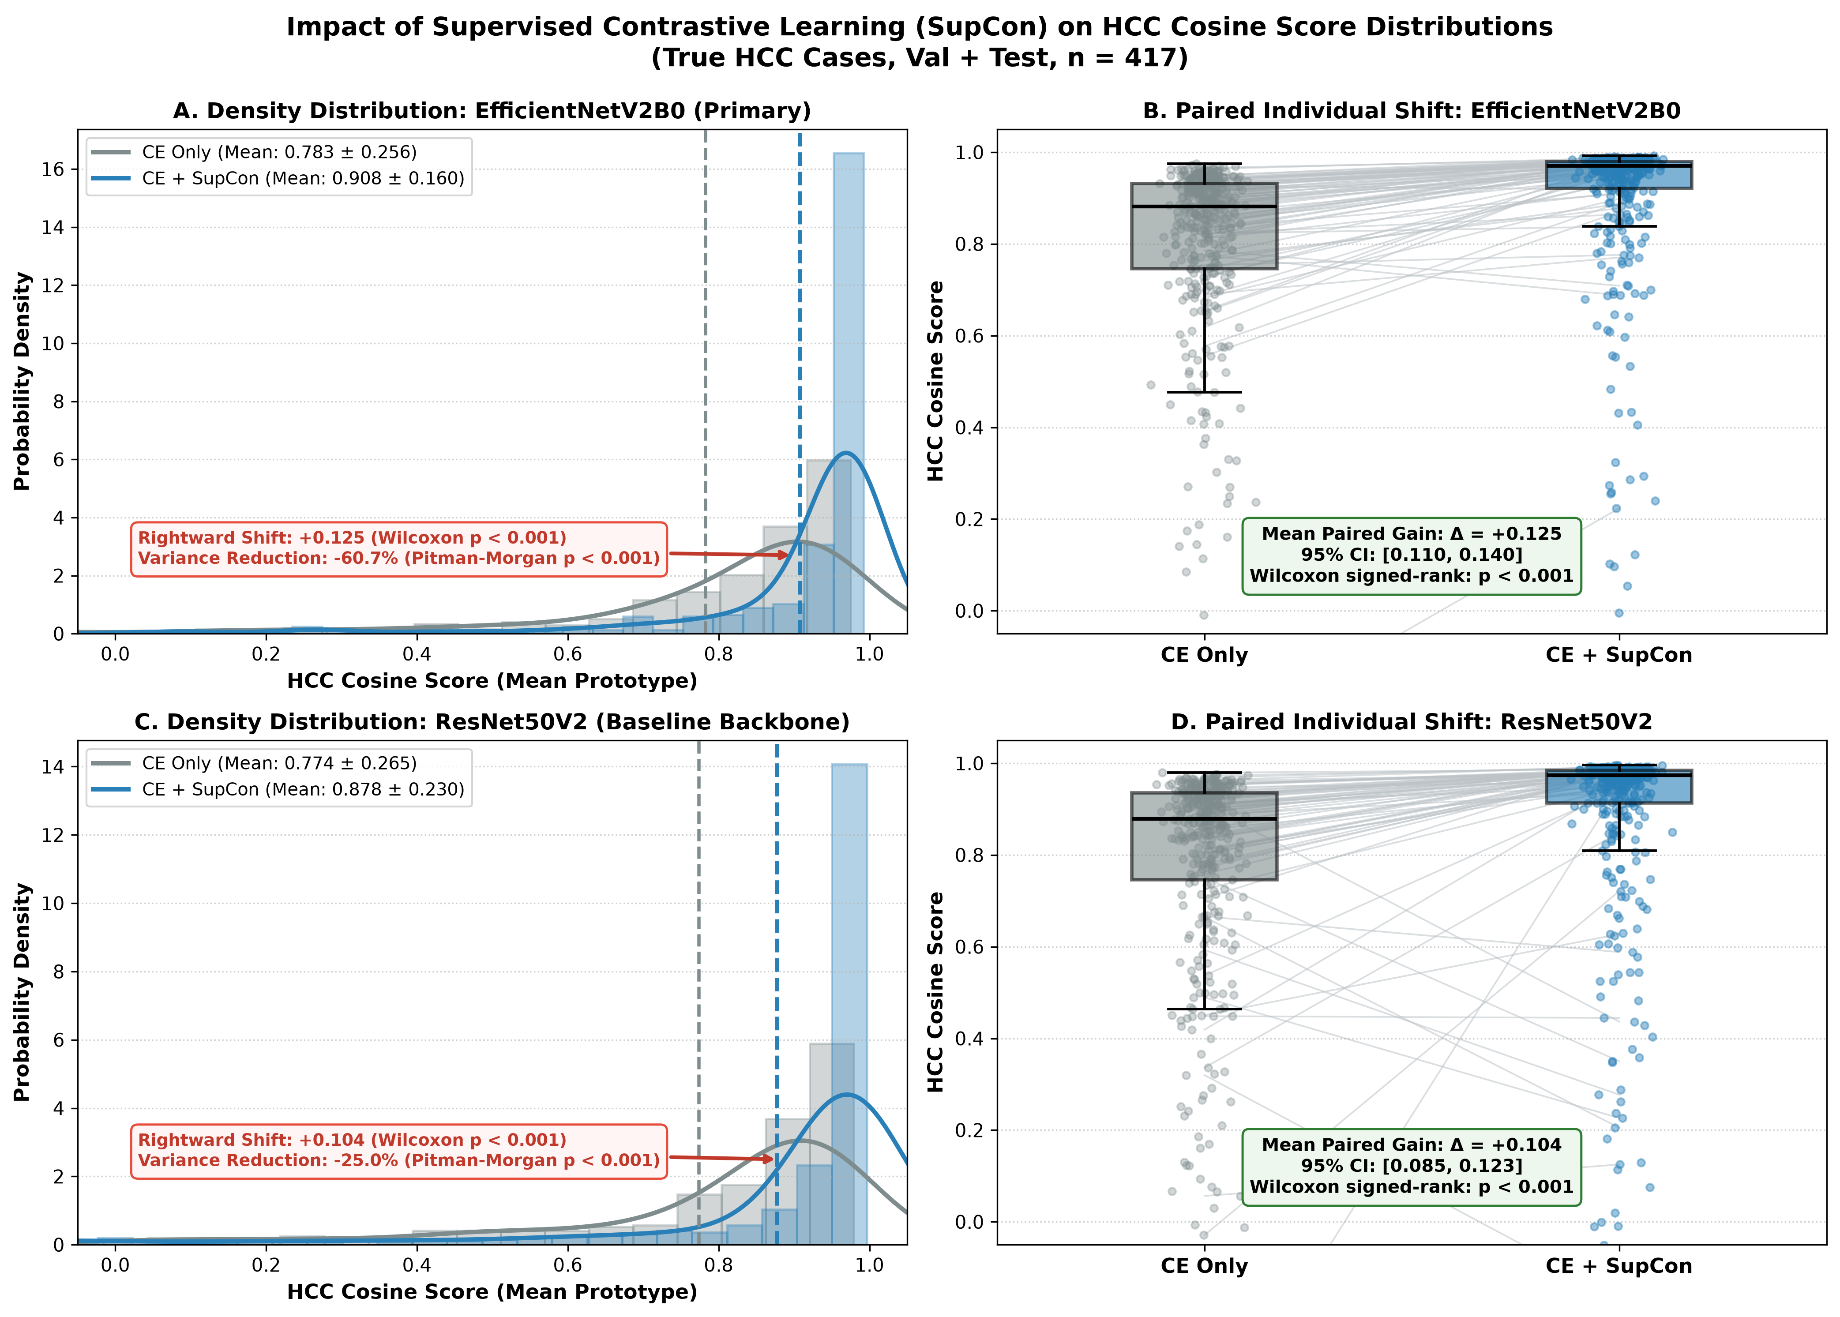
Figure 4. HCC Cosine Score Distributions with and without Supervised Contrastive Learning (SupCon) in True HCC Cases (n=417; Validation 277 + Test 140).
The same 417 HCC images not included in training (validation 277; test 140) were paired across CE-only and CE+SupCon conditions. Each model used its own training-set mean HCC prototype; differences therefore reflect the model–prototype pipeline rather than a fixed common embedding coordinate system. Panels A and C show density distributions; B and D show paired scores for EfficientNetV2B0 and ResNet50V2, respectively. Values are mean ± SD. EfficientNetV2B0: 0.783 ± 0.256 (median 0.882) versus 0.908 ± 0.160 (median 0.970); mean paired difference +0.125 (95% CI 0.110–0.140); paired t=16.94; Wilcoxon signed-rank p < 0.001; 94.7% of scores increased; rounded variance 0.065 versus 0.026 (60.7% reduction; Pitman-Morgan t=16.84, p < 0.001). ResNet50V2: 0.774 ± 0.265 versus 0.878 ± 0.230; mean paired difference +0.104 (95% CI 0.085–0.123); paired t=10.98; Wilcoxon p < 0.001; rounded variance 0.070 versus 0.053 (25.0% reduction as annotated in the supplied figure; Pitman-Morgan t=4.06, p < 0.001). Confidence intervals and tests are image-level and do not account for intra-patient correlation. A shift in score distribution does not establish improved classification or clinical utility. CE, cross-entropy; SupCon, supervised contrastive learning.
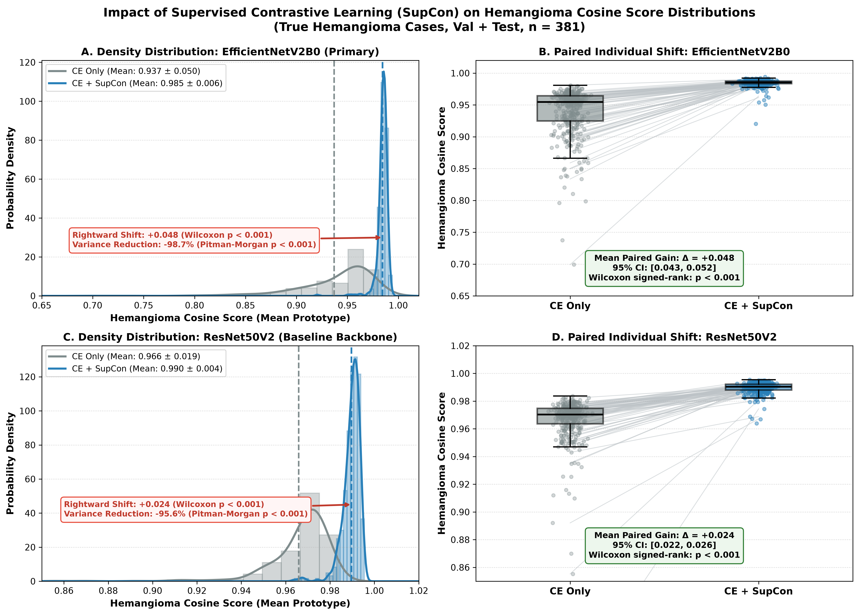
Figure 5. Hemangioma Cosine Score Distributions with and without Supervised Contrastive Learning (SupCon) in True Hemangioma Cases (n=381; Validation 253 + Test 128).
The same 381 hemangioma images not included in training (validation 253; test 128) were paired across CE-only and CE+SupCon conditions. Each model used its own training-set mean hemangioma prototype. Panels A and C show density distributions; B and D show paired scores for EfficientNetV2B0 and ResNet50V2, respectively. Values are mean ± SD. EfficientNetV2B0: 0.937 ± 0.050 (median 0.955) versus 0.985 ± 0.006 (median 0.985); mean paired difference +0.048 (95% CI 0.043–0.052); paired t=19.71; Wilcoxon signed-rank p < 0.001; rounded variance 0.00253 versus 0.00003 (98.7% reduction as annotated in the figure; Pitman-Morgan t=106.23, p < 0.001). ResNet50V2: 0.966 ± 0.019 versus 0.990 ± 0.004; mean paired difference +0.024 (95% CI 0.022–0.026); paired t=26.54; Wilcoxon p < 0.001; rounded variance 0.00036 versus 0.00002 (95.6% reduction as annotated in the figure; Pitman-Morgan t=49.18, p < 0.001). Relative variance reductions should be interpreted alongside the small baseline variances and the upper bound of cosine similarity; rounded variances should not be used to reconstruct these percentages. Confidence intervals and tests are image-level and do not account for intra-patient correlation. These plots describe score distributions, not calibrated disease probabilities or proof of diagnostic benefit.

